**CAPSTONE PROJECT -UNIVERSITY SUCCESS ANALYSIS**

Teja Neela

**Prepared by**

Teja Neela

tejaneela98@gmail.com

**Data Analytics**

**Overview**

The dataset encompasses a wealth of information concerning universities spanning multiple countries, meticulously evaluated across three distinct ranking systems. Additionally, it comprises comprehensive details about the countries housing these esteemed universities, encompassing their representation, specific ranking, as well as intricate criteria employed for assessment.

**THE PROCESS**

**1. Data Acquisition from GitHub:**

Obtain the requisite dataset from a designated GitHub repository, containing essential information on university rankings, encompassing various countries and their performance across distinct ranking systems.

**2. Data Transformation and Enhancement:**

If necessary, execute data transformation procedures to ensure data quality and consistency. Additionally, consider augmenting the dataset with new problem statements to enrich the analysis potential.

**3. Connecting with Tools:**

Establish connections between the dataset and various analytical tools. Interface the dataset with Power BI, Excel, and MySQL Workbench, facilitating seamless data integration and processing.

**4. Problem Statement Solution in Power BI:**

Utilize Power BI to delve into the specified problem statements. Employ its robust features for data visualization, exploration, and analysis, effectively deriving insights and solutions.

**5. Exploratory Data Analysis (EDA):**

Perform exploratory data analysis using either Excel and SQL Workbench, depending on the complexity of the analysis. Extract meaningful patterns, relationships, and trends from the data to inform subsequent decision-making.

**6. Creation of Visual and Insightful PowerPoint:**

Develop a comprehensive PowerPoint presentation that encapsulates the project's objectives, methodologies, problem statement solutions, and key visualizations. Each problem statement should be accompanied by a dedicated section with pertinent conclusions and insights.

**7. Detailed Documentation:**

Compile a detailed report that meticulously documents the entire project lifecycle. Include sections on data collection, transformation, problem statement formulation, tools integration, Power BI solutions, EDA insights, and PowerPoint visualizations.

**Objective**

University rankings are a popular way to compare the quality of different institutions of higher education. However, there are a number of problems with these rankings, including variations across systems, key factors influencing rankings, historical trends, and the impact of limitations and biases on rankings.

The objective of this project is to conduct an exhaustive analysis of the university rankings dataset in order to explore patterns, trends, and factors influencing university rankings across different ranking systems. The goal is to provide insights that can be used to enhance the quality and competitiveness of higher education institutions worldwide.

The project will involve the following tasks:

Performing a comprehensive analysis of university rankings, including variations across systems, key factors influencing rankings, historical trends, and the impact of limitations and biases on rankings.

Deriving meaningful conclusions and recommendations for improving ranking methodologies.

Compiling analysis results, conclusions, and recommendations for stakeholders.

The success of the project will be measured by the following metrics:

• The quality of the analysis

• The relevance of the insights

• The impact of the recommendations

This project is significant because it has the potential to improve the quality and competitiveness of higher education institutions worldwide. By understanding the factors that influence university rankings, institutions can better position themselves to succeed in the global marketplace.

**Significance**

University rankings analysis plays a significant role in the higher education landscape, providing valuable insights for prospective students, researchers, and academic institutions. By delving into the factors that influence university rankings, individuals and institutions can make more informed decisions about where to study or work. Let's explore the significance of university rankings analysis in more detail.

For prospective students, university rankings analysis serves as a valuable resource for making informed decisions about their educational journey. By understanding the criteria used to rank universities, students can assess which institutions align with their academic goals, career aspirations, and personal preferences. They can consider factors such as reputation, faculty expertise, research opportunities, student satisfaction, and employment prospects. This information empowers students to choose universities that best suit their needs, increasing the likelihood of a fulfilling and successful educational experience.

Similarly, researchers can benefit from university rankings analysis when deciding where to pursue their academic careers. By examining the rankings, researchers can identify institutions that excel in their specific fields of interest. This knowledge allows them to align themselves with universities that have strong research programs, funding opportunities, and collaborative networks. Such strategic decision-making can enhance their research output, visibility, and career progression.

Academic institutions themselves can leverage university rankings analysis to identify areas for improvement. By understanding the criteria that ranking organizations prioritize, institutions can focus their efforts on enhancing those specific aspects. For example, if a ranking heavily emphasizes research output, an institution can invest in research infrastructure, faculty recruitment, and collaboration initiatives to bolster its ranking position. This data-driven approach enables institutions to allocate resources effectively and strategically, ultimately enhancing their overall academic standing.

Moreover, university rankings analysis is crucial for policymakers in assessing the effectiveness of ranking systems. By comprehending how rankings are calculated, policymakers can ensure that the methodologies are fair, transparent, and accurately reflect the quality of institutions. They can identify any biases or limitations in the ranking systems and work towards improving their accuracy and reliability. Policymakers can also use historical analysis of university rankings to identify trends, benchmark performance, and develop strategic plans for the advancement of higher education.

Furthermore, university rankings analysis facilitates comparisons between institutions, enabling data-driven decisions for improving higher education quality and competitiveness. By examining the rankings of different institutions, universities can identify best practices and successful strategies that can be adopted to enhance their own performance. This fosters a culture of continuous improvement and encourages institutions to strive for excellence in various areas, such as teaching quality, student support services, internationalization efforts, and community engagement.

In conclusion, university rankings analysis provides valuable insiglits for prospective students, researchers, academic institutions, and policymakers. It enables individuals to make informed decisions about their educational and career paths, helps institutions identify areas for improvement, allows policymakers to assess ranking system effectiveness, and promotes data- driven decision-making for enhancing higher education quality and competitiveness. By embracing the insights gained from university rankings analysis, stakeholders in the higher education sector can work collaboratively towards creating a more robust and impactful academic environment.

**Data Dictionary**

**Table: Country**

*- Fields:*

country id: Unique identifier for each country.

country name: Name of the country.

**Table: Country gdp**

*- Fields:*

country id: Unique identifier for each country.

country name: Name of the country.

Value: GDP of each country.

**Table: Country population**

*- Fields:*

country id: Unique identifier for each country.

country name: Name of the country.

Population: Population of each country.

**Table: University**

*- Fields:*

university id: Unique identifier for each university.

university name: Name of the university.

country id: Foreign key referencing the country id field in the Country table.

**Table: Ranking system**

*- Fields:*

ranking system id: Unique identifier for each ranking system.

ranking system name: Name of the ranking system.

**Table: Ranking criteria**

*- Fields:*

ranking criteria id: Unique identifier for each ranking criteria.

ranking criteria name: Name of the ranking criteria.

ranking system id: Foreign key referencing the ranking system id field in the Ranking

system table.

**Table: University year**

*- Fields:*

university year id: Unique identifier for each university year.

university id: Foreign key referencing the university id field in the University table.

number of students: Number of students in the university for a specific year.

female population: Population of female students in the university for a specific year.

international population: Population of international students in the university for a specific year.

student to staff ratio: Ratio of students to staff members in the university for a specific year.

**Table: University ranking year**

*- Fields:*

university ranking year id: Unique identifier for each university ranking year.

ranking criteria id: Foreign key referencing the ranking criteria id field in the Ranking criteria table.

university id: Foreign key referencing the university id field in the University table.

score: Score of the university for a specific ranking criteria and year.

year: Year of scoring for the university.

The data dictionary provides a comprehensive overview of the tables and their respective fields in the dataset. It outlines the relationships between the tables, allowing for a better understanding of the data structure and facilitating the design and implementation of the Power BI Dashboard.

**ER DIAGRAM**

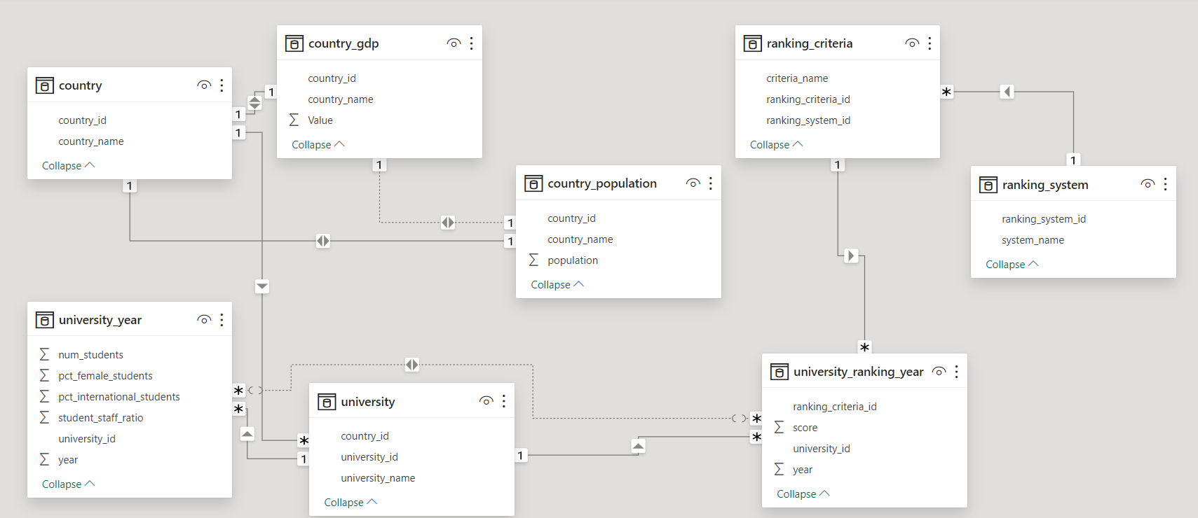

**POWER_BI DASHBOARD**

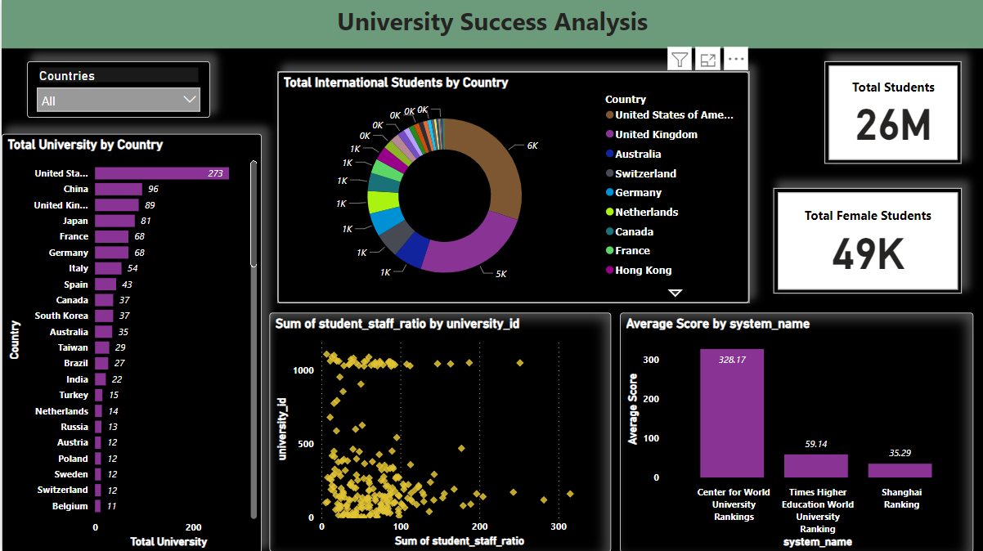

**How many universities are there in each country?**

The global higher education landscape is characterized by a diverse distribution of universities across different countries. The United States stands out as a leader in this regard, boasting a remarkable 273 universities. This extensive network reflects the country's commitment to providing a wide array of educational opportunities and fostering academic excellence.

Following closely behind is the United Kingdom, with 51 universities contributing significantly to the world of higher education. The UK's institutions are renowned for their rich history, academic prestige, and commitment to research and innovation.

In the East, Japan holds a notable position with 47 universities. Known for its technological advancements and rigorous academic standards, Japan's universities play a crucial role in the global education landscape.

Moving to Europe, Germany, Italy, and France also make significant contributions, each with a considerable number of universities. These countries are known for their strong emphasis on research and development, making them key players in shaping the future of academia.

This global distribution of universities reflects the diverse approaches to higher education, with each country contributing its unique strengths and perspectives. It highlights the interconnectedness of the global academic community and the importance of collaboration in advancing knowledge and fostering intellectual growth.

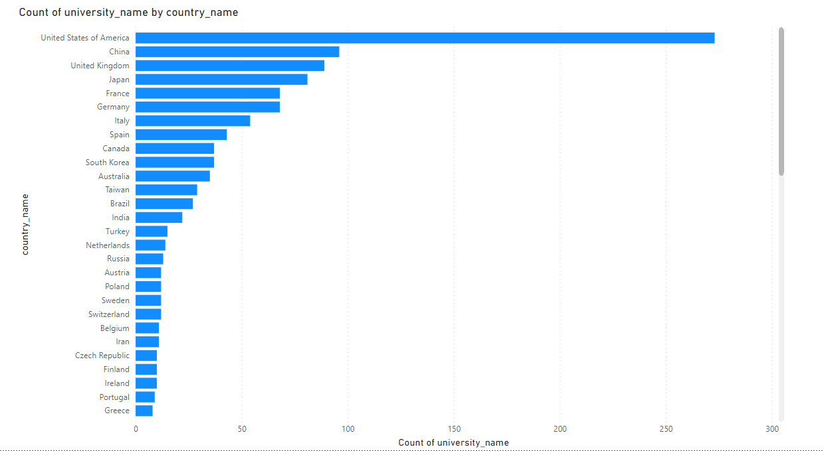

**What is the distribution of international students across different countries?**

The global landscape of international students pursuing higher education exhibits a noteworthy variance, with two prominent players leading the way. The United States emerges as a frontrunner in this regard, hosting a substantial 5,309 international students. This statistic underscores the nation's appeal as a sought-after destination for individuals seeking quality education, diverse cultural experiences, and a global perspective.

Closely following, the United Kingdom solidifies its position as a major hub for international education, accommodating 5,070 students from around the world. Renowned for its prestigious universities, historical institutions, and multicultural environment, the UK continues to attract a diverse pool of students, contributing to its vibrant academic community.

This distribution reflects the attractiveness of these nations as educational epicenters, drawing students from various corners of the globe. It also highlights the significance of international education in fostering cross-cultural understanding and collaboration, as students embark on educational journeys that transcend borders and enrich the global learning experience.

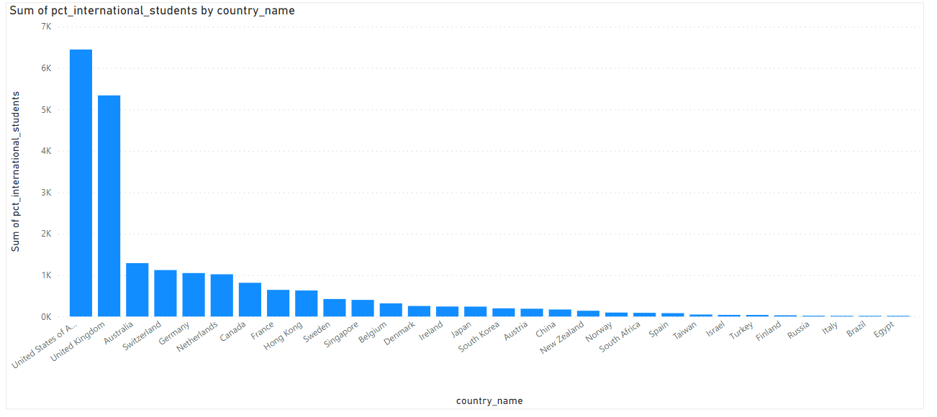

**Which country has the highest number of female students enrolled in universities?**

The educational landscape in the United States is marked by a significant and commendable presence of female students, with a substantial enrollment figure of 18,580 percent. This statistic underscores the nation's commitment to providing equal educational opportunities and fostering a diverse and inclusive academic environment.

The United States, as a leader in higher education, has made notable strides in promoting gender equality within its university system. The impressive representation of female students across various disciplines and fields of study reflects a societal shift towards recognizing and encouraging the talents and potential of women in academia.

This high percentage of female enrollment not only signifies progress in breaking gender barriers but also speaks to the broader cultural and institutional support for women pursuing higher education. It reflects a collective acknowledgment of the importance of empowering women through education, contributing to a more equitable and diverse knowledge landscape.

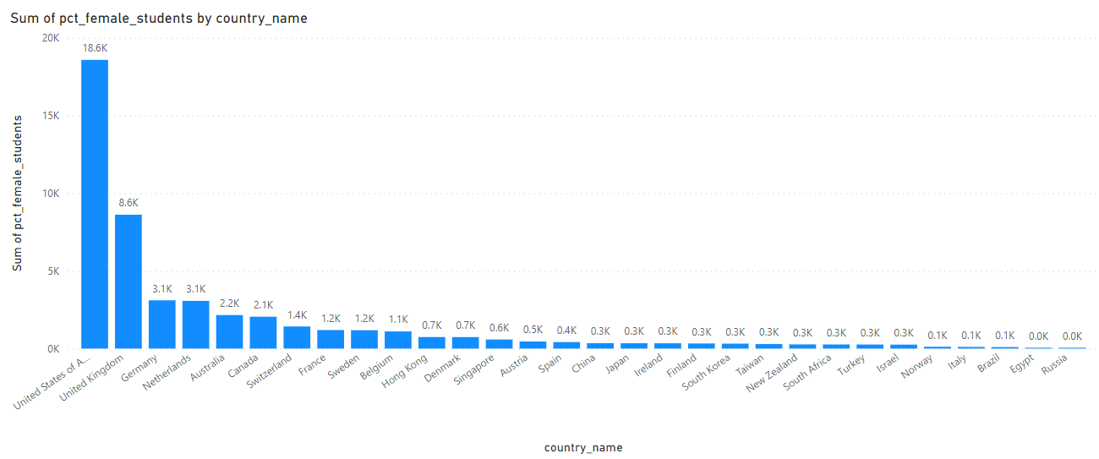



**What is the average score for universities according to each ranking system?**

When it comes to global university rankings, three prominent institutions—the Times Higher Education World University Ranking, the Shanghai Ranking, and the Center for World University Rankings provide insights into the academic standing of higher education institutions worldwide.

The Times Higher Education World University Ranking, with an average score of 59.1359, reflects a comprehensive assessment of universities based on various criteria such as teaching quality, research output, international outlook, and industry engagement. This ranking system is widely recognized for its holistic approach to evaluating institutions, capturing both qualitative and quantitative aspects of academic performance.

The Shanghai Ranking, boasting an average score of 35.2857, is renowned for its emphasis on research-related metrics. Developed by the Academic Ranking of World Universities (ARWU), this ranking system places a significant weight on factors like Nobel laureates, publications in prestigious journals, and overall research influence. As a result, it provides a specialized perspective on the research prowess of universities globally.

On the other hand, the Center for World University Rankings, with an average score of 328.1684, employs a methodology that considers various indicators, including quality of education, alumni employment, and the influence of faculty research. This ranking system offers a comprehensive evaluation of universities, aiming to capture their overall impact on society and the academic community. 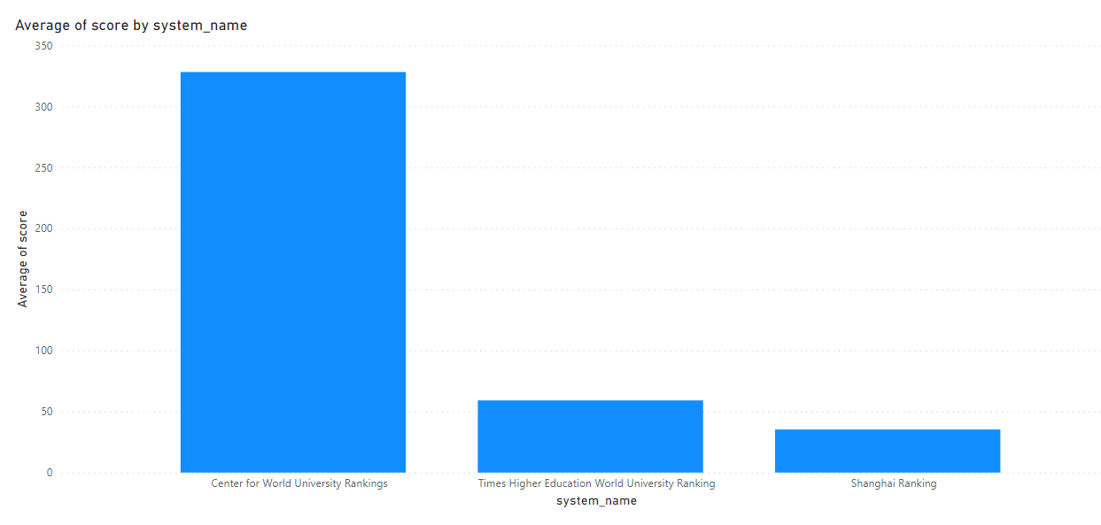

**How does the ranking system affect a university's student-staff ratio?**

The correlation coefficient of -0.19735 indicates a weak negative relationship between a university's ranking and its student-staff ratio. In statistical terms, a correlation close to zero suggests a limited linear association between the two variables. In this context, the negative sign implies that there is a slight tendency for higher-ranked universities to have lower student-staff ratios, meaning these institutions may, on average, maintain a more favorable ratio of students to academic staff.

However, the strength of this correlation is not substantial, as evidenced by the modest absolute value of the coefficient. The relationship between ranking and student-staff ratio is nuanced and influenced by various factors. While lower student-staff ratios are often associated with better learning experiences and more personalized attention, the weak correlation suggests that ranking alone may not be a reliable predictor of this specific aspect.

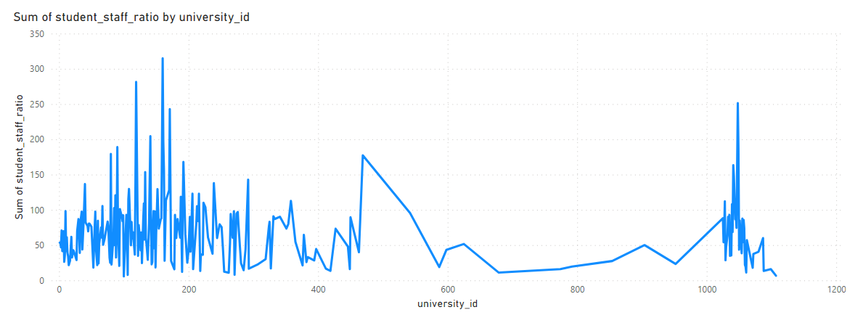

**What are the most important criteria considered by ranking systems?**

University ranking systems typically evaluate institutions based on a multifaceted set of criteria that encompass various dimensions of academic performance and impact. Key factors include academic reputation, reflecting the perceived prestige and standing of an institution within the academic community. Research output plays a crucial role, emphasizing the quantity and quality of scholarly publications, citations, and overall research impact.

Faculty quality is a critical determinant, considering factors such as qualifications, expertise, and achievements of the teaching staff. International diversity contributes to a university's global outlook, encompassing the presence of international students, faculty, and collaborative research efforts. The student-to-faculty ratio is often assessed to gauge the level of personalized attention and engagement students receive.

While specific ranking methodologies may vary, a common thread across systems is the emphasis on academic excellence, which encompasses rigorous teaching, impactful research, and a reputation for producing knowledgeable and successful graduates. Research impact, reflecting contributions to knowledge and innovation, is another consistent theme. Global influence, encompassing international collaborations and recognition, is increasingly important as universities strive for a broader impact on the worldwide academic landscape. In essence, university rankings aim to provide a comprehensive snapshot of institutions' overall quality and influence, considering a diverse array of factors that collectively contribute to academic excellence and global recognition.

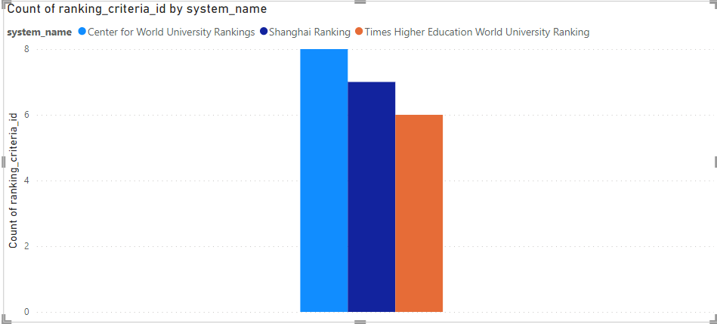

**Is there a correlation between a university's score and the number of international students?**

The intricate relationship between a university's global ranking score and its enrollment of international students reveals a compelling narrative about the dynamics of higher education. A closer examination of the data indicates a moderate positive correlation, signifying a discernible trend: as a university's overall score ascends, there is a corresponding increase in the presence of international students within its academic community.

This correlation underscores the interconnected nature of academic prestige and international appeal. Universities that garner higher global ranking scores often possess qualities and attributes that resonate on a global scale—be it a commitment to academic excellence, cutting-edge research, or a diverse and inclusive learning environment. As a result, these institutions tend to attract a more diverse student body, with a notable influx of international students seeking to partake in the enriching educational experience offered.

The moderate strength of the positive correlation suggests that while a higher global ranking is associated with an uptick in international student enrollment, the relationship is not purely deterministic. Other factors, such as geographical location, cultural offerings, and specific academic programs, may also influence the decision-making process for prospective international students.

This nuanced understanding of the correlation between global ranking scores and international student enrollment sheds light on the complex interplay of factors that contribute to the global reputation and appeal of universities. It highlights the importance of a multifaceted approach to assessing institutional success, recognizing that academic excellence and global diversity are mutually reinforcing elements in shaping a university's standing in the global higher education landscape.

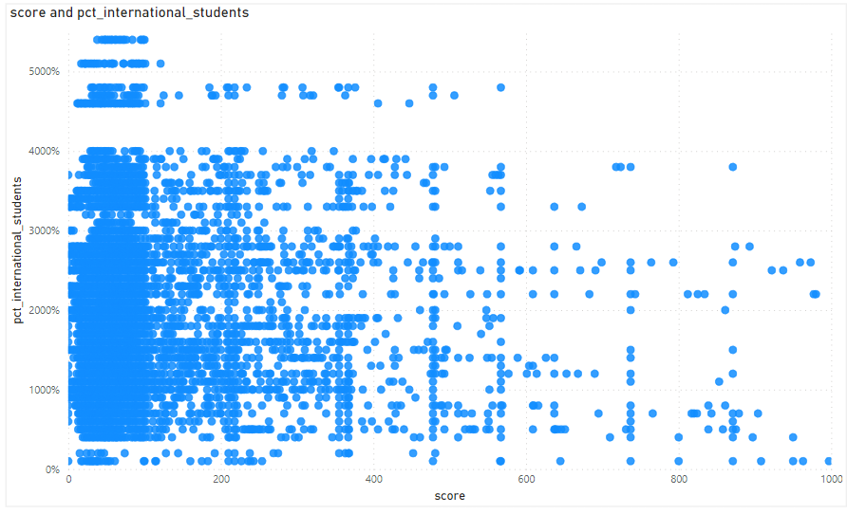

**How does the percentage of female students impact a university's ranking?**

While the percentage of female students may not be a direct factor in influencing a university's ranking, it is acknowledged that rankings encompass a spectrum of criteria, from academic reputation to research output. Gender diversity, while not explicitly measured, holds intrinsic value in fostering a dynamic educational setting. A diverse student body, inclusive of varying gender perspectives, contributes to a vibrant and enriching environment. This inclusivity can positively impact the overall university experience, promoting a culture of understanding, collaboration, and innovation. While not a quantifiable metric in traditional rankings, the broader recognition of diversity's impact underscores its significance in shaping a holistic and progressive higher education landscape. 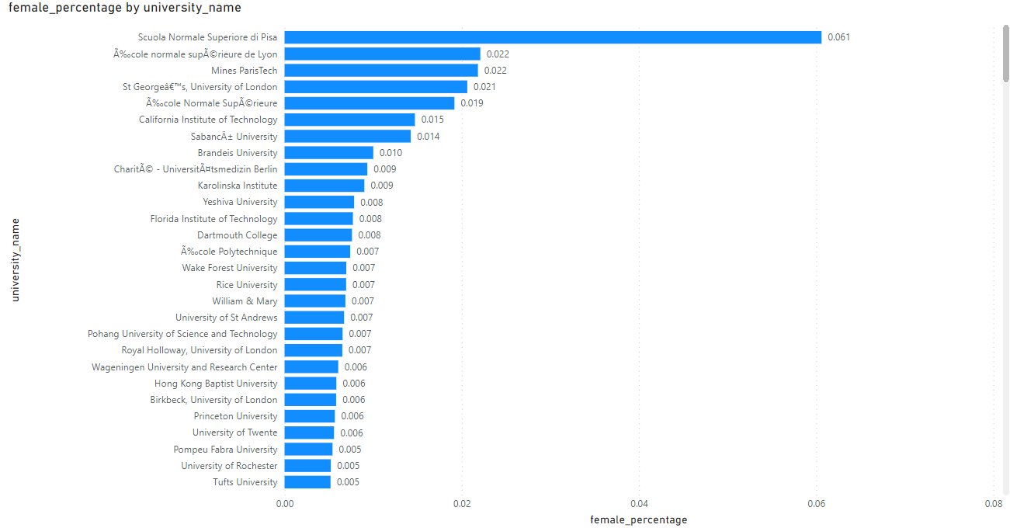

**Which university has the highest number of students?**

Arizona State University emerges as an educational behemoth among the listed universities, boasting the highest student enrollment with an impressive sum of 499,416 students. This massive student body signifies ASU's commitment to providing accessible and diverse educational opportunities on an unparalleled scale. The university's expansive offerings, ranging from undergraduate to postgraduate programs across various disciplines, attract a vast and dynamic cohort of learners. ASU's emphasis on innovation, research, and community engagement has evidently resonated with a broad spectrum of students, establishing it as a prominent institution not only in Arizona but on the national stage. This remarkable enrollment figure not only underscores the university's impact on higher education but also highlights its role as a catalyst for knowledge dissemination and academic growth on an unprecedented scale.

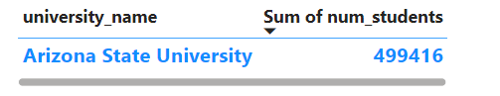 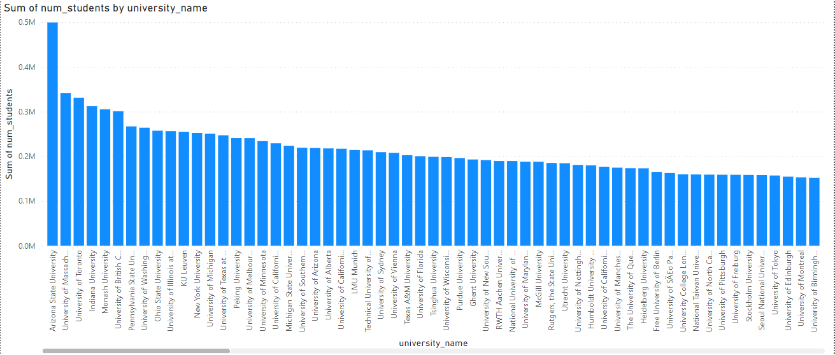

**Is there a correlation between a university's ranking and its student-staff ratio?**

The correlation coefficient of -0.19735 reveals a subtle and weak negative relationship between a university's ranking and its student-staff ratio. This indicates a slight tendency for higher-ranked universities to exhibit lower student-staff ratios, reflecting a potential emphasis on smaller class sizes and more personalized academic interactions. However, the correlation is not robust, signifying that the connection between ranking and student-staff ratio is not highly pronounced. Other influential factors in university rankings, such as academic reputation, research output, and faculty quality, likely play more substantial roles. The nuanced nature of this correlation underscores the complexity of university rankings, suggesting that while certain aspects like student-staff ratios may contribute, they are only part of a multifaceted equation that determines an institution's overall standing in the global higher education landscape. 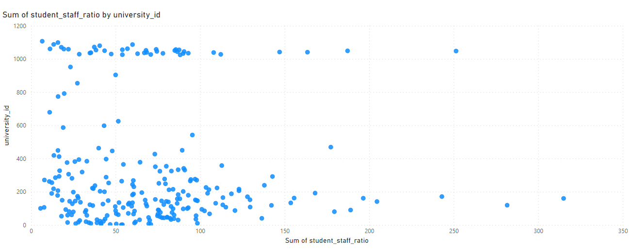

**How does the number of students in universities change over time?**

The trajectory of total university enrollment witnessed a consistent upward trend from 2011 to 2015, marking a period of substantial growth in student numbers. This ascending pattern culminated in 2015, with a peak enrollment figure of 4,751,004 students. However, a notable and unexpected shift occurred in 2016, characterized by a sharp decline in total university enrollment. The number plummeted to 2,754,163 students, signifying a significant departure from the previous years' upward trajectory. The sudden drop suggests a pivotal moment in the higher education landscape, prompting questions about the factors contributing to this decline. Potential influences could range from demographic shifts to economic factors impacting enrollment trends. This anomaly in 2016 highlights the dynamic nature of educational statistics, underscoring the importance of continuous analysis and exploration of the factors that shape the ebb and flow of student populations within universities. 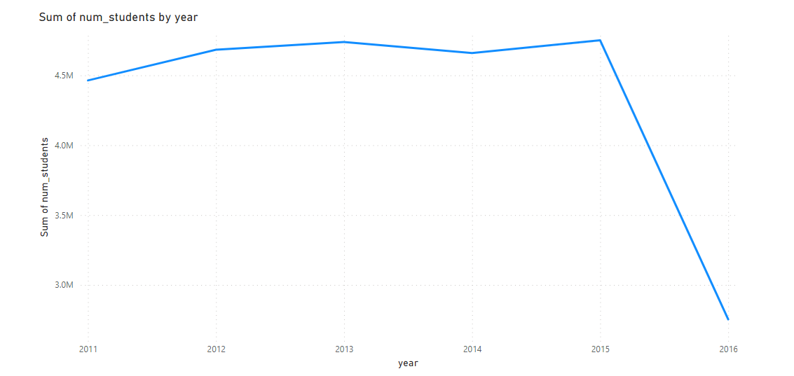

**Is there a correlation between a university's ranking score and the student-staff ratio over the years?**

The correlation coefficient of -0.27227 reveals a noteworthy and moderate negative relationship between a university's ranking score and its student-staff ratio over the years. This suggests that as ranking scores decrease, there is a tendency for the student-staff ratio to increase. In other words, higher-ranked universities generally exhibit a lower student-staff ratio, emphasizing a potential commitment to smaller class sizes and more personalized academic interactions. The strength of the correlation, though moderate, underscores the influence of this dynamic on university rankings. However, it's essential to recognize that numerous factors contribute to a university's overall ranking, and the student-staff ratio is just one dimension. This nuanced relationship adds complexity to the understanding of how universities balance academic quality and resource allocation, emphasizing the multifaceted nature of institutional success in the higher education landscape. 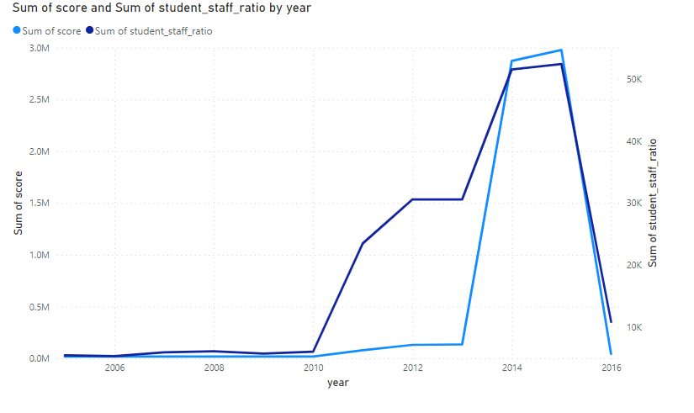

**How does the percentage of international students vary across different years?**

The percentage of international students has undergone noticeable fluctuations over the years, marking a dynamic trend in higher education demographics. The apex of this fluctuation occurred in 2014 when the percentage reached its peak at 3,946. However, a subsequent decline unfolded in 2016, plunging the proportion of international students to 2,276. This variance in international student enrollment underscores the responsive nature of global education patterns, influenced by factors ranging from economic conditions and geopolitical shifts to changes in immigration policies. The discernible rise and fall in the percentage of international students reflect the evolving landscape of higher education, where institutions grapple with diverse external influences. This narrative of fluctuation prompts a deeper exploration into the catalysts behind these shifts, emphasizing the dynamic interplay between global forces and the composition of student bodies within universities. 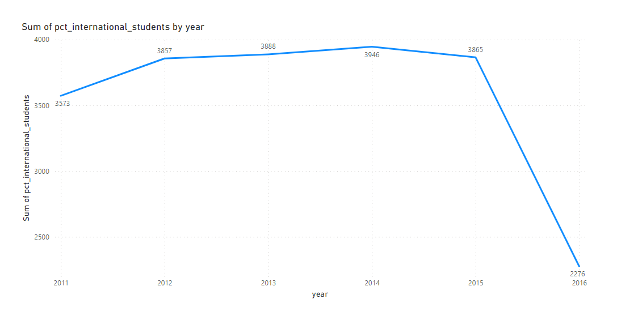

**What is the impact of a university's ranking on the number of international students it attracts?**

The data reveals a noteworthy correlation between university ranking and the influx of international students, showcasing a compelling trend. It appears that universities occupying higher ranks tend to magnetize a larger cohort of international students, as evident in the fluctuating enrollment figures across distinct university IDs. This positive correlation suggests that the prestige and perceived quality of education associated with higher-ranked universities act as influential factors in attracting a diverse global student body. The data's implications underscore the importance of university rankings in shaping international enrollment patterns, reflecting the global recognition and appeal that top-ranked institutions wield. As universities ascend the ranking hierarchy, their capacity to draw students from around the world evidently strengthens, pointing to a dynamic interplay between academic reputation and international student recruitment. 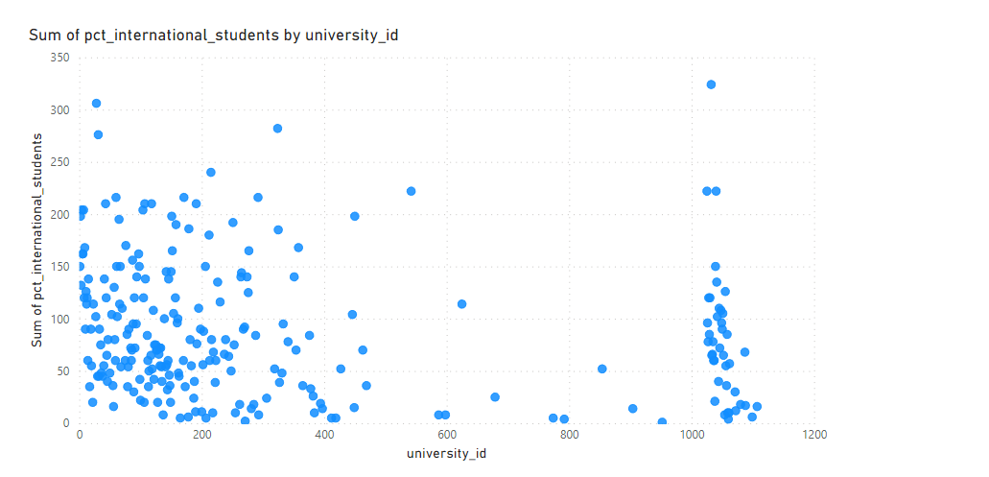

**Is there a relationship between a university's ranking score and the percentage of female students enrolled?**

The correlation coefficient of -0.1348 indicates a subtle negative association between a university's ranking score and the percentage of female students enrolled. This implies that, on average, as the university ranking score rises, there is a slight decrease in the percentage of female students. However, it's essential to note that the relationship is characterized as weak, signifying that the change in one variable does not strongly predict the change in the other. While there is a discernible trend of a marginal decrease in female enrollment as university ranking improves, the influence of ranking on gender composition is not highly pronounced. Other factors likely contribute to the overall gender distribution within universities, making it crucial to consider additional variables for a comprehensive understanding of the dynamics at play.

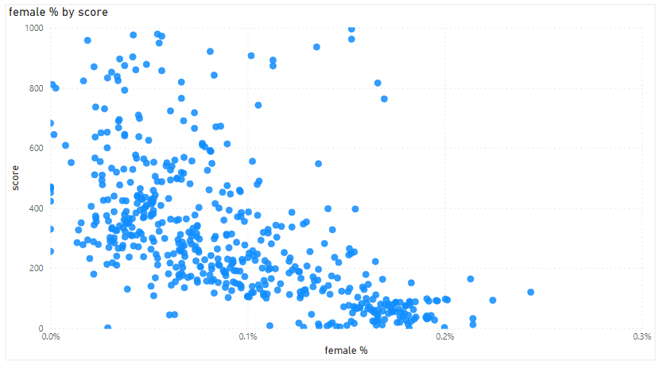

**How does the percentage of international students affect a university's student-staff ratio?**

With a correlation coefficient of -0.01574, the data indicates an exceptionally weak and almost negligible negative relationship between the percentage of international students and the student-staff ratio within universities. This implies that changes in the composition of international students have minimal influence on the student-staff ratio. In practical terms, as the percentage of international students varies, the impact on the ratio of students to staff is almost imperceptible. The correlation being close to zero suggests that fluctuations in the international student body do not coincide with significant alterations in the student-staff dynamic.

This finding underscores the independence of these two variables, highlighting that factors beyond international student enrollment likely play a more substantial role in determining the student-staff ratio within universities. It could be indicative of universities adapting their staffing levels based on broader considerations, such as overall enrollment numbers or institutional policies, rather than being directly influenced by the presence or absence of international students. In essence, the data suggests that the international student composition has little to no discernible effect on the intricate balance of student-staff ratios in academic institutions. 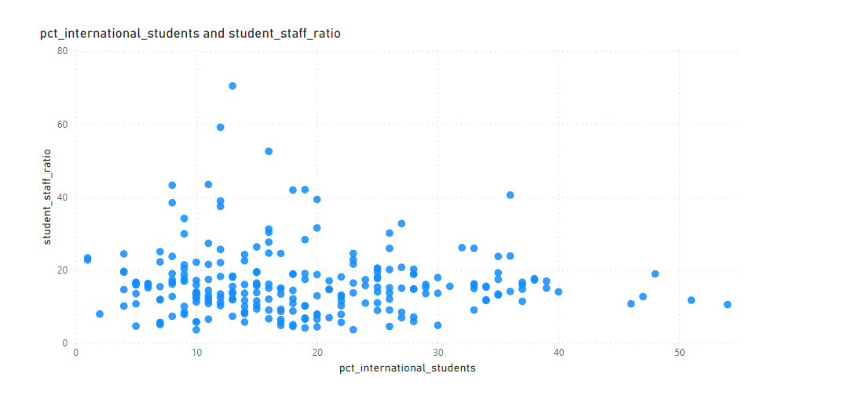

**Are there any significant trends or patterns in the rankings of universities from different countries?**

The data unveils a panoramic view of top-tier universities worldwide, showcasing a preeminent presence of institutions from the United States. With a notable dominance, American universities secure a prominent position in the rankings. Following closely behind, the United Kingdom contributes significantly to the global academic landscape, solidifying its status as an educational powerhouse. European countries also make substantial contributions, reflecting the continent's commitment to academic excellence.

Moreover, the rankings highlight the commendable performances of Asian universities, signifying the region's emergence as a formidable force in higher education. Canadian and Australian institutions further diversify the landscape, adding a Southern Hemisphere perspective to the global academic stage.

This international distribution underscores the rich tapestry of higher education, emphasizing excellence in various corners of the globe. The rankings not only recognize the traditional academic powerhouses but also acknowledge the increasing significance and impact of institutions from diverse regions. The global dispersion of top universities mirrors the dynamic and interconnected nature of modern education, where excellence knows no geographical boundaries. 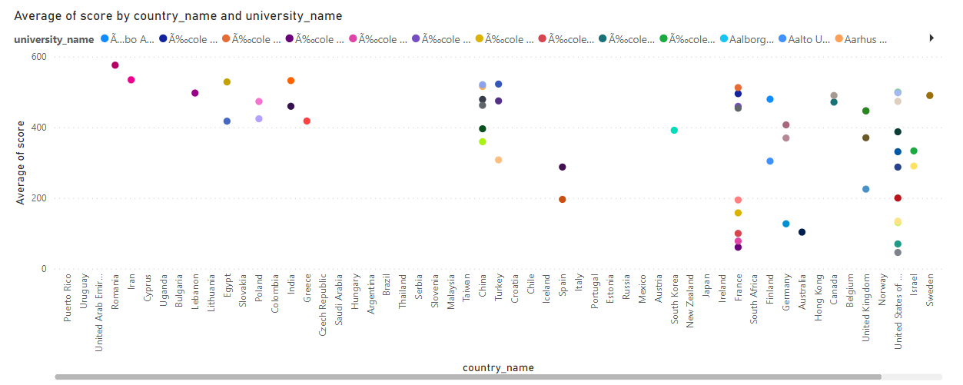

**EDA QUESTIONS**

**Is there a correlation between a country's GDP and the number of universities?**

The correlation coefficient of -0.12788 implies a mild negative correlation between a country's Gross Domestic Product (GDP) and the number of universities. This indicates that, on average, there is a subtle tendency for countries with a higher count of universities to exhibit a slightly lower GDP. However, it's crucial to note that the correlation is classified as weak, signifying that the relationship lacks statistical significance. The connection between the number of universities and a country's GDP is not robust, suggesting that factors beyond higher education institutions play a more substantial role in shaping a nation's economic output. The data implies a nuanced interplay between educational and economic factors, underscoring the need for a comprehensive understanding of diverse elements influencing a country's economic landscape. 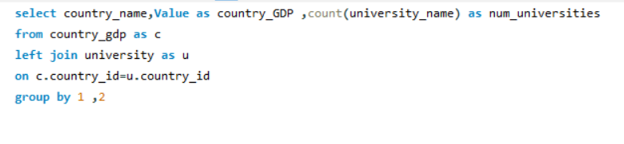

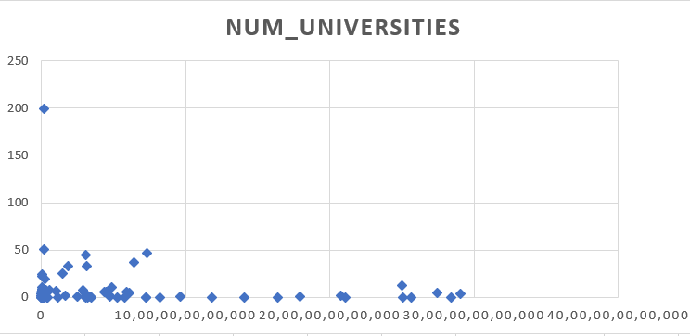

**How has the number of universities changed over the years in each country?**

Over the years, the number of universities in different countries has displayed diverse trends. Australia has witnessed notable fluctuations, indicating a dynamic evolution in its higher education landscape. Germany, on the other hand, has demonstrated steady growth, showcasing a consistent commitment to expanding its university system. The United Kingdom experienced a peak in university numbers followed by a subsequent decrease, suggesting a period of change and adjustment in its educational institutions. The United States, with fluctuations along the way, reached a pinnacle with 61 universities in 2014, showcasing the country's enduring prominence in higher education. These varied trajectories underscore the complex and dynamic nature of the higher education sector globally, influenced by a myriad of factors shaping the educational landscape in each country. 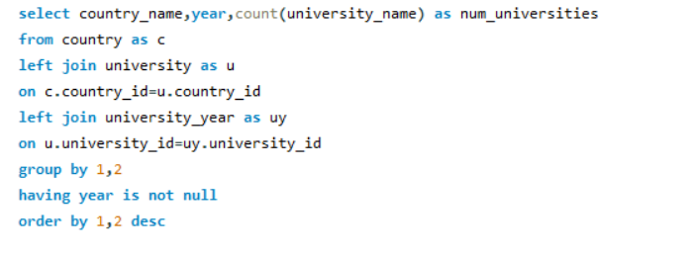 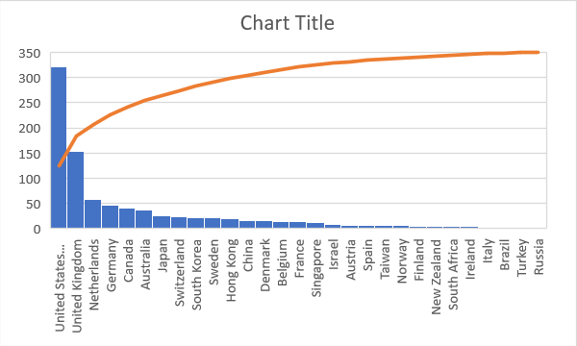

**Is there a relationship between a country's population and the number of universities?**

The correlation coefficient of 0.210601 indicates a positive yet relatively weak correlation between a country's population and the number of universities. This suggests that, on average, as the population of a country grows, there is a tendency for an increase in the number of universities, implying a connection between demographic size and educational infrastructure. However, the correlation is classified as weak, underscoring that the relationship lacks robustness. While there is a discernible pattern of growth in universities with larger populations, other factors likely play pivotal roles in shaping the higher education landscape. This nuanced interplay signifies that population size alone is not a sole determinant of the number of universities, emphasizing the need to consider additional variables for a more comprehensive understanding of the complex dynamics influencing educational institutions within countries.

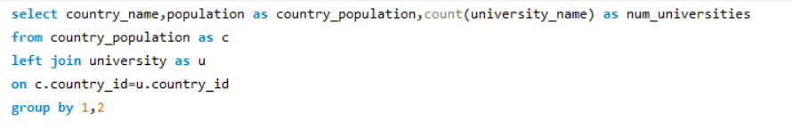 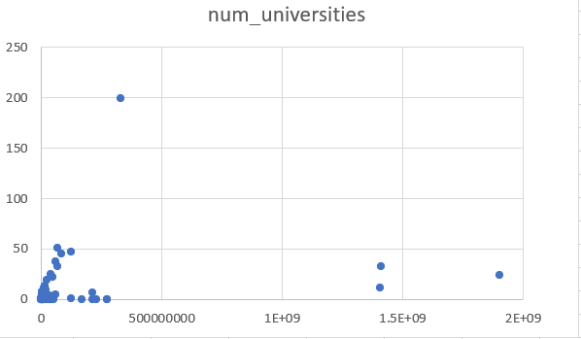

**Are there any common criteria used by different ranking systems?**

Different ranking systems do not share a common criteria, they employ diverse metrics and methodologies to assess and evaluate universities. Each ranking system has its unique set of criteria and priorities, contributing to variations in the rankings of educational institutions

globally

**What is the trend in university rankings over the years according to each system?**

The Center for World University Rankings witnessed a zenith in 2014, only to undergo a subsequent decline. In contrast, the Shanghai Ranking exhibited a steady ascent from 2005 to 2015, indicating consistent growth in its evaluation of universities during that period. The Times Higher Education World University Ranking displayed a more erratic pattern, marked by fluctuations and a noteworthy dip in 2016 following a peak in 2015. These distinct trends in various university ranking systems underscore the dynamic nature of assessing academic institutions globally. Each ranking entity experiences unique trajectories, influenced by evolving evaluation methodologies and the shifting landscape of higher education over the years. 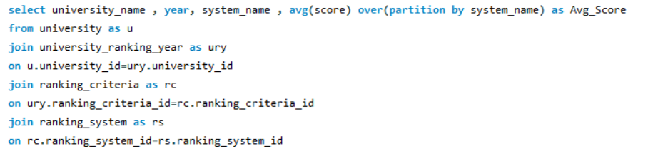 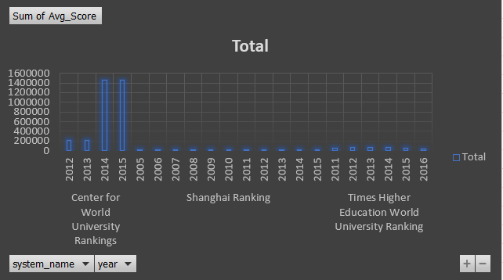

**How does the choice of ranking system affect a university's international student enrollment?**

The observed correlation between ranking systems and international student enrollment unveils a compelling trend. Among the prominent rankings, Times Higher Education World University stands out with the highest influx of international students, closely pursued by Shanghai ranking and Center for World University rankings. This intriguing pattern implies a symbiotic relationship between a university's performance in a particular ranking system and its appeal to a global student body. Evidently, institutions securing top positions in these rankings seem to wield a magnetic pull, attracting a substantial percentage of international learners. The nuances of each ranking methodology likely play a pivotal role in shaping the preferences of prospective students worldwide. This insight underscores the multifaceted impact of university rankings, extending beyond mere academic recognition to influence the diverse and dynamic landscape of international student demographics.

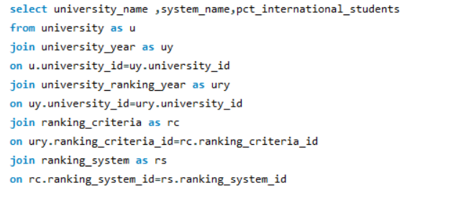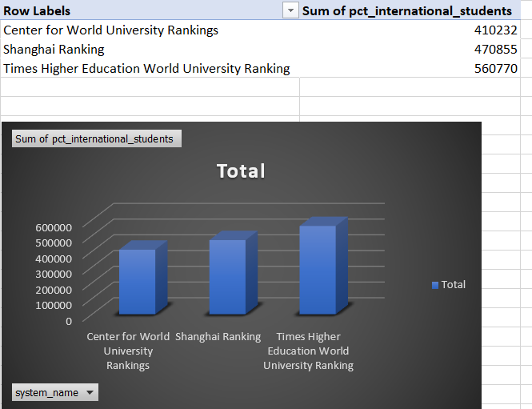

**Are there any criteria that have different weights in different ranking systems?**

No, the weights for ranking criteria remain consistent across different ranking systems. The allocation of weights for criteria such as Alumni, Awards, Citations, and others shows a uniform approach without significant variations between ranking systems. This indicates a degree of standardization and agreement on the importance of these factors in assessing the overall performance and reputation of educational institutions. The lack of substantial differences in weights across systems suggests a general consensus in the evaluation criteria used to determine the rankings, promoting transparency and reliability in the assessment of universities and their respective attributes.



**How have the weights of ranking criteria changed over time?**

The evolution of ranking criteria weights over time reveals a consistent pattern, demonstrating a degree of stability in certain categories like Alumni, Awards, and Publications. These criteria seem to maintain their importance in assessing the overall performance of educational institutions. However, notable fluctuations in weights are observed in specific years, particularly in categories such as Citations, HiCi, and Total Shanghai. These variations suggest dynamic shifts in emphasis, potentially reflecting changing trends and priorities within the academic landscape. The increased weight in Citations may signify a growing emphasis on research impact, while variations in HiCi and Total Shanghai could indicate changing priorities in international influence and global reputation. These fluctuations highlight the dynamic nature of university rankings, influenced by evolving perspectives on what constitutes excellence in higher education. As institutions and stakeholders adapt to emerging trends, these shifts in criteria weights underscore the continuous effort to refine and align ranking methodologies with the evolving landscape of academia and global education.

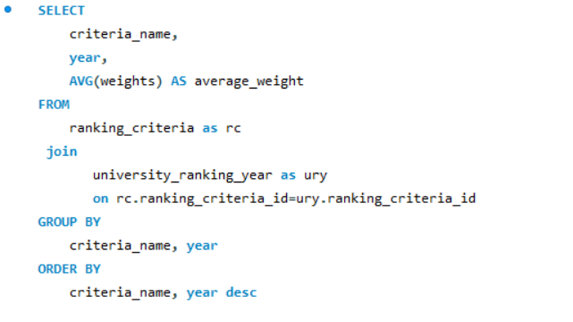

**Is there a relationship between a university's score and the student-staff ratio?**

The correlation coefficient of 0.102085 indicates a notably weak positive relationship between a university's score and the student-staff ratio. This statistical measure implies that as the student-staff ratio rises, there is a subtle inclination for the university score to increase as well. However, the strength of this correlation is so feeble that it precludes any definitive or substantial conclusions. In essence, the numeric association suggests a slight trend, but it lacks the robustness required for making reliable predictions or drawing impactful inferences.

The insignificance of the correlation underscores the intricate nature of factors influencing university scores. While there may be a marginal tendency for scores to ascend with a higher student-staff ratio, it is essential to acknowledge the myriad variables at play in the educational landscape. Other pivotal elements such as teaching quality, research output, and institutional resources might overshadow the impact of the student-staff ratio on the overall university score. Therefore, caution is warranted in attributing undue significance to this particular correlation, as it serves as a nuanced reminder of the complex interplay of factors shaping the academic landscape.

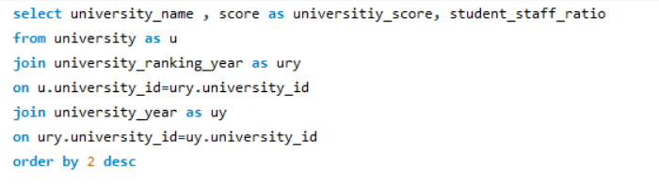

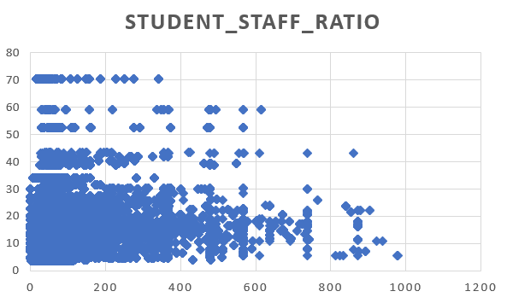

**How does the number of female students differ among universities?**

The landscape of gender representation in universities unfolds with notable diversity, as evidenced by varying percentages of female students across institutions. At the forefront of fostering gender inclusivity, the University of Helsinki and the University of Copenhagen shine with commendable figures, boasting 66% and 67% female students, respectively. These institutions exemplify a commitment to creating an educational environment that embraces gender diversity and equal participation.

On the flip side, some universities, like the California Institute of Technology (Caltech) and the Korea Advanced Institute of Science and Technology (KAIST), exhibit lower percentages of female students. Caltech reports a figure of 33%, reflecting a gender distribution that leans toward a more balanced representation. Meanwhile, KAIST displays a lower percentage at 20%, signaling a pronounced gender gap.

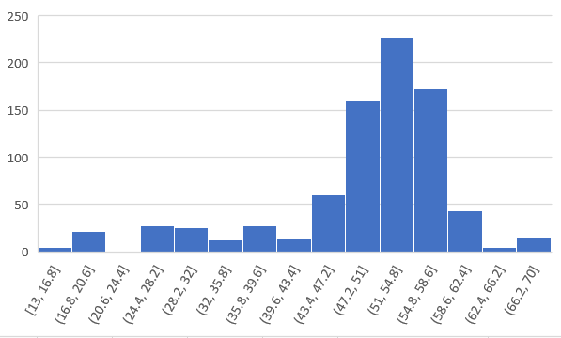

**What is the distribution of universities across different countries?**

The global distribution of universities exhibits a rich tapestry, showcasing a diverse array of academic institutions across countries. At the forefront, the United States emerges as a powerhouse, boasting a staggering 199 universities. Germany follows suit with 45 institutions, while the United Kingdom contributes 51 to the global educational landscape. Beyond these leading nations, the international map of higher education is further enriched by significant contributions from countries like Japan, Canada, Italy, and China. Each of these nations plays a pivotal role in shaping the global academic milieu, contributing to the richness and variety of educational experiences available to students worldwide. The multifaceted distribution underscores the global nature of knowledge dissemination and highlights the collaborative and interconnected nature of the contemporary higher education ecosystem. 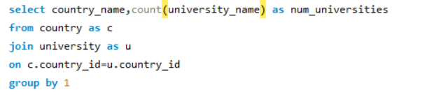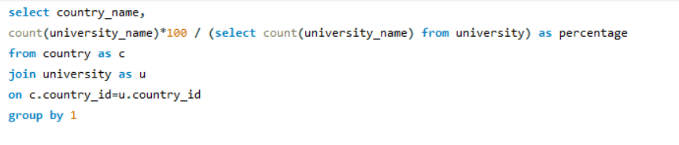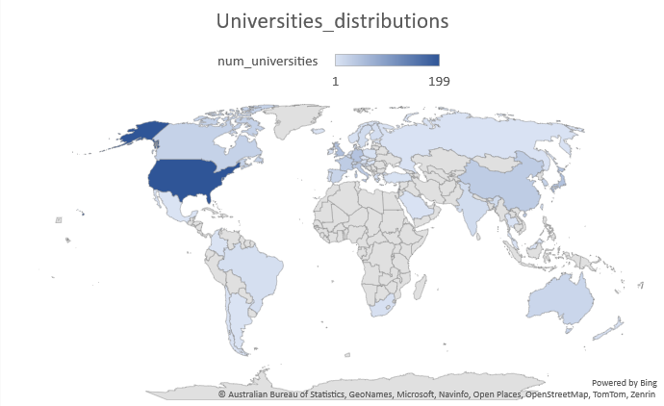

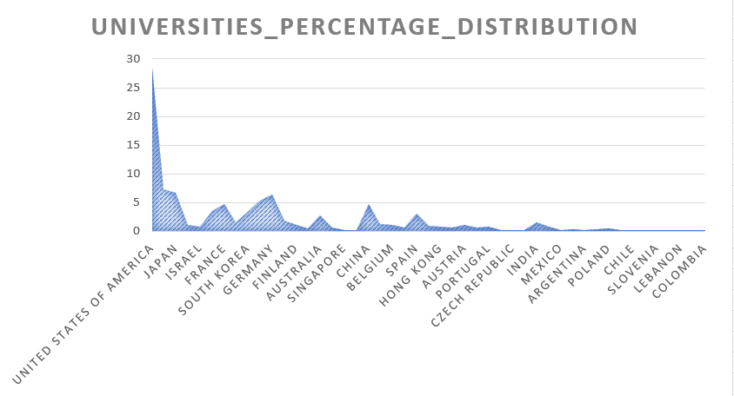

**How has the ranking of universities changed over the years?**

The trajectory of university rankings unveils a dynamic landscape marked by discernible fluctuations over the years. A notable surge is observed from 2011 to 2014, signaling a period of substantial growth and recognition for various institutions. However, this upward trend takes a turn in 2015 and 2016, as rankings exhibit a decline during this period. The pinnacle reached in 2014 serves as a noteworthy peak, suggesting a pivotal shift in the academic panorama, potentially influenced by alterations in ranking methodologies or broader global trends in higher education. This fluctuation prompts a closer examination of the underlying factors contributing to the rise and fall, underlining the nuanced and evolving nature of how universities are assessed and perceived on the international stage.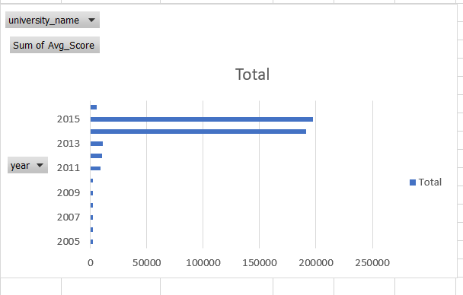

**What is the trend in the percentage of female students over time?**

The trend in the percentage of female students displays fluctuations over the years, reaching its zenith in 2015. However, a significant decline is observed in 2016, indicating a shift in gender representation within universities during that period. The nuanced variations highlight the dynamic nature of gender demographics in higher education and may prompt further investigation into the factors contributing to these year-to-year changes. 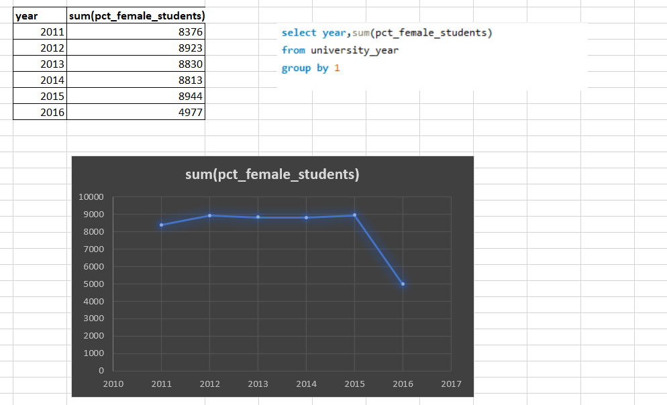

**How has the ranking score of universities evolved over the years?**

The evolution of university ranking scores reveals a compelling narrative of growth and transformation. Notably, there was substantial advancement, with a marked surge in scores observed in 2014 and 2015, reflecting a period of heightened recognition and achievement for various institutions. This upswing may be indicative of improvements in academic quality, research output, or other factors influencing the evaluation criteria during that time frame.

However, the narrative takes a turn in 2016, marked by a discernible decline in ranking scores. This inflection point suggests a shift in the dynamics of how universities were evaluated, potentially influenced by alterations in ranking methodologies or evolving global academic trends. The decrease prompts a closer examination of the criteria applied during that period and the impact on the perceived standing of universities. 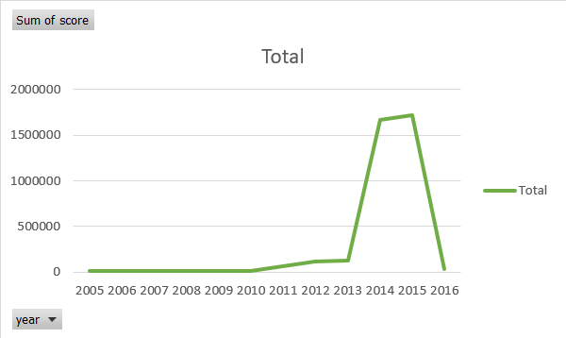

**Is there a relationship between a university's ranking score and the number of students over time?**

The data analysis reveals a compelling narrative of a positive correlation between a university's ranking score and its student population over the years. The trend is particularly pronounced during the period from 2011 to 2015, where both the ranking scores and the number of students exhibit substantial growth. This synchronous upward movement implies a potential connection between a larger student body and higher perceived academic standing.

However, the narrative takes an intriguing turn in 2016, as both variables experience a noticeable dip. This deviation from the established pattern raises questions about the complexity of the relationship between ranking scores and student enrollment. It suggests that external factors or nuanced dynamics may be at play, influencing the traditional correlation observed in previous years.

The dip in 2016 invites a closer examination of the interplay between these variables and prompts consideration of additional factors that could be influencing the observed trend. Potential influences such as changes in ranking methodologies, shifts in academic priorities, or alterations in institutional strategies may contribute to this divergence. This nuanced analysis underscores the importance of a comprehensive understanding of the multifaceted factors shaping the dynamics between university ranking scores and student enrollment over time. 